WEEK 2:PL SQL

EXERCISE 1-CONTROL STRUCTURES

SET SERVEROUTPUT ON;

CREATE TABLE Customers (

CustomerID NUMBER PRIMARY KEY,

Name VARCHAR2(100),

DOB DATE,

Balance NUMBER,

LastModified DATE,

IsVIP CHAR(1) DEFAULT 'N'

);

CREATE TABLE Accounts (

AccountID NUMBER PRIMARY KEY,

CustomerID NUMBER,

AccountType VARCHAR2(20),

Balance NUMBER,

LastModified DATE,

FOREIGN KEY (CustomerID) REFERENCES Customers(CustomerID)

);

CREATE TABLE Transactions (

TransactionID NUMBER PRIMARY KEY,

AccountID NUMBER,

TransactionDate DATE,

Amount NUMBER,

TransactionType VARCHAR2(10),

FOREIGN KEY (AccountID) REFERENCES Accounts(AccountID)

);

CREATE TABLE Loans (

LoanID NUMBER PRIMARY KEY,

CustomerID NUMBER,

LoanAmount NUMBER,

InterestRate NUMBER,

StartDate DATE,

EndDate DATE,

FOREIGN KEY (CustomerID) REFERENCES Customers(CustomerID)

);

CREATE TABLE Employees (

EmployeeID NUMBER PRIMARY KEY,

Name VARCHAR2(100),

Position VARCHAR2(50),

Salary NUMBER,

Department VARCHAR2(50),

HireDate DATE

);

INSERT INTO Customers (CustomerID, Name, DOB, Balance, LastModified)

VALUES (1, 'John Doe', TO_DATE('1950-05-15', 'YYYY-MM-DD'), 12000, SYSDATE);

INSERT INTO Customers (CustomerID, Name, DOB, Balance, LastModified)

VALUES (2, 'Jane Smith', TO_DATE('1990-07-20', 'YYYY-MM-DD'), 1500, SYSDATE);

INSERT INTO Accounts (AccountID, CustomerID, AccountType, Balance, LastModified)

VALUES (1, 1, 'Savings', 1000, SYSDATE);

INSERT INTO Accounts (AccountID, CustomerID, AccountType, Balance, LastModified)

VALUES (2, 2, 'Savings', 1500, SYSDATE);

INSERT INTO Transactions (TransactionID, AccountID, TransactionDate, Amount, TransactionType)

VALUES (1, 1, SYSDATE, 200, 'Deposit');

INSERT INTO Transactions (TransactionID, AccountID, TransactionDate, Amount, TransactionType)

VALUES (2, 2, SYSDATE, 300, 'Withdrawal');

INSERT INTO Loans (LoanID, CustomerID, LoanAmount, InterestRate, StartDate, EndDate)

VALUES (1, 1, 5000, 5, SYSDATE, ADD_MONTHS(SYSDATE, 60));

INSERT INTO Loans (LoanID, CustomerID, LoanAmount, InterestRate, StartDate, EndDate)

VALUES (2, 2, 8000, 6, SYSDATE, SYSDATE + 15); -- Due within 30 days

INSERT INTO Employees (EmployeeID, Name, Position, Salary, Department, HireDate)

VALUES (1, 'Alice Johnson', 'Manager', 70000, 'HR', TO_DATE('2015-06-15', 'YYYY-MM-DD'));

INSERT INTO Employees (EmployeeID, Name, Position, Salary, Department, HireDate)

VALUES (2, 'Bob Brown', 'Developer', 60000, 'IT', TO_DATE('2017-03-20', 'YYYY-MM-DD'));

SET SERVEROUTPUT ON;

BEGIN

-- 1st Scenario: Reduce InterestRate for customers older than 60

FOR rec IN (

SELECT l.LoanID

FROM Loans l

JOIN Customers c ON l.CustomerID = c.CustomerID

WHERE FLOOR(MONTHS_BETWEEN(SYSDATE, c.DOB) / 12) > 60

) LOOP

UPDATE Loans

SET InterestRate = InterestRate - 1

WHERE LoanID = rec.LoanID;

END LOOP;

-- 2nd Scenario: Mark VIP Customers and Print Details

UPDATE Customers

SET IsVIP = 'Y'

WHERE Balance > 10000;

DBMS_OUTPUT.PUT_LINE('--- Customer Details ---');

FOR rec IN (

SELECT CustomerID, Name, TO_CHAR(DOB, 'YYYY-MM-DD') AS DOB_FMT,

Balance, TO_CHAR(LastModified, 'YYYY-MM-DD') AS LastMod,

IsVIP

FROM Customers

) LOOP

DBMS_OUTPUT.PUT_LINE(

'ID: ' || rec.CustomerID ||

', Name: ' || rec.Name ||

', DOB: ' || rec.DOB_FMT ||

', Balance: ' || rec.Balance ||

', LastModified: ' || rec.LastMod ||

', IsVIP: ' || rec.IsVIP

);

DBMS_OUTPUT.PUT_LINE('-----');

END LOOP;

-- 3rd Scenario: Loan Due Reminders within 30 days

DBMS_OUTPUT.PUT_LINE('--- Upcoming Loan Dues ---');

FOR rec IN (

SELECT l.LoanID, c.Name, TO_CHAR(l.EndDate, 'YYYY-MM-DD') AS DueDate

FROM Loans l

JOIN Customers c ON l.CustomerID = c.CustomerID

WHERE l.EndDate BETWEEN SYSDATE AND SYSDATE + 30

) LOOP

DBMS_OUTPUT.PUT_LINE(

'Reminder: Loan ID ' || rec.LoanID ||

' for customer ' || rec.Name ||

' is due on ' || rec.DueDate

);

END LOOP;

END;

/  
  
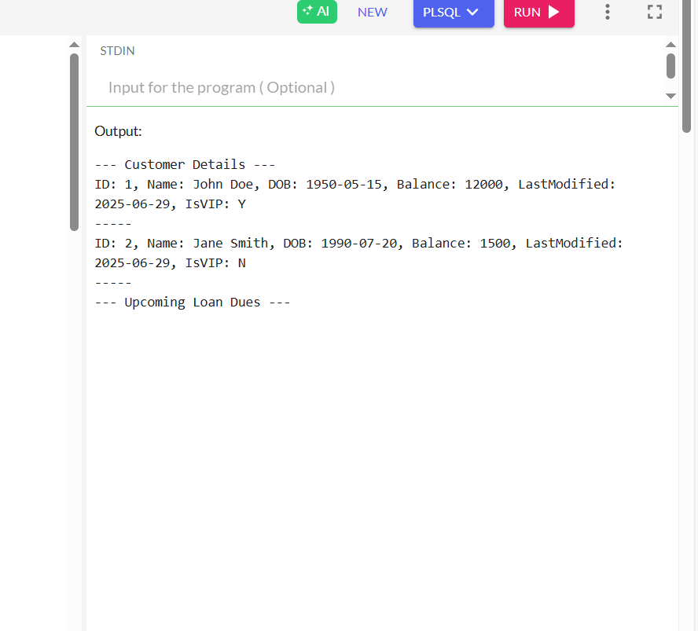

WEEK 2:PL SQL  
 EXERCISE 3:STORED PROCEDURES

SET SERVEROUTPUT ON;

CREATE TABLE Customers (

CustomerID NUMBER PRIMARY KEY,

Name VARCHAR2(100),

DOB DATE,

Balance NUMBER,

LastModified DATE,

IsVIP CHAR(1) DEFAULT 'N'

);

CREATE TABLE Accounts (

AccountID NUMBER PRIMARY KEY,

CustomerID NUMBER,

AccountType VARCHAR2(20),

Balance NUMBER,

LastModified DATE,

FOREIGN KEY (CustomerID) REFERENCES Customers(CustomerID)

);

CREATE TABLE Transactions (

TransactionID NUMBER PRIMARY KEY,

AccountID NUMBER,

TransactionDate DATE,

Amount NUMBER,

TransactionType VARCHAR2(10),

FOREIGN KEY (AccountID) REFERENCES Accounts(AccountID)

);

CREATE TABLE Loans (

LoanID NUMBER PRIMARY KEY,

CustomerID NUMBER,

LoanAmount NUMBER,

InterestRate NUMBER,

StartDate DATE,

EndDate DATE,

FOREIGN KEY (CustomerID) REFERENCES Customers(CustomerID)

);

CREATE TABLE Employees (

EmployeeID NUMBER PRIMARY KEY,

Name VARCHAR2(100),

Position VARCHAR2(50),

Salary NUMBER,

Department VARCHAR2(50),

HireDate DATE

);

INSERT INTO Customers (CustomerID, Name, DOB, Balance, LastModified)

VALUES (1, 'John Doe', TO_DATE('1950-05-15', 'YYYY-MM-DD'), 12000, SYSDATE);

INSERT INTO Customers (CustomerID, Name, DOB, Balance, LastModified)

VALUES (2, 'Jane Smith', TO_DATE('1990-07-20', 'YYYY-MM-DD'), 1500, SYSDATE);

INSERT INTO Accounts (AccountID, CustomerID, AccountType, Balance, LastModified)

VALUES (1, 1, 'Savings', 1000, SYSDATE);

INSERT INTO Accounts (AccountID, CustomerID, AccountType, Balance, LastModified)

VALUES (2, 2, 'Savings', 1500, SYSDATE);

INSERT INTO Transactions (TransactionID, AccountID, TransactionDate, Amount, TransactionType)

VALUES (1, 1, SYSDATE, 200, 'Deposit');

INSERT INTO Transactions (TransactionID, AccountID, TransactionDate, Amount, TransactionType)

VALUES (2, 2, SYSDATE, 300, 'Withdrawal');

INSERT INTO Loans (LoanID, CustomerID, LoanAmount, InterestRate, StartDate, EndDate)

VALUES (1, 1, 5000, 5, SYSDATE, ADD_MONTHS(SYSDATE, 60));

INSERT INTO Loans (LoanID, CustomerID, LoanAmount, InterestRate, StartDate, EndDate)

VALUES (2, 2, 8000, 6, SYSDATE, SYSDATE + 15); -- Due within 30 days

INSERT INTO Employees (EmployeeID, Name, Position, Salary, Department, HireDate)

VALUES (1, 'Alice Johnson', 'Manager', 70000, 'HR', TO_DATE('2015-06-15', 'YYYY-MM-DD'));

INSERT INTO Employees (EmployeeID, Name, Position, Salary, Department, HireDate)

VALUES (2, 'Bob Brown', 'Developer', 60000, 'IT', TO_DATE('2017-03-20', 'YYYY-MM-DD'));

-- first scenario

CREATE OR REPLACE PROCEDURE ProcessMonthlyInterest AS

BEGIN

UPDATE Accounts

SET Balance = Balance * 1.01

WHERE AccountType = 'Savings';

COMMIT;

END;

/

-- 2nd scenario

CREATE OR REPLACE PROCEDURE UpdateEmployeeBonus(

p_department IN VARCHAR2,

p_bonus_percent IN NUMBER

) AS

BEGIN

UPDATE Employees

SET Salary = Salary + (Salary * p_bonus_percent / 100)

WHERE Department = p_department;

COMMIT;

END;

/

BEGIN

UpdateEmployeeBonus('IT', 10);

END;

/

-- 3rd scenario

CREATE OR REPLACE PROCEDURE TransferFunds(

p_from_account IN NUMBER,

p_to_account IN NUMBER,

p_amount IN NUMBER

) AS

v_balance NUMBER;

BEGIN

SELECT Balance INTO v_balance

FROM Accounts

WHERE AccountID = p_from_account;

IF v_balance < p_amount THEN

RAISE_APPLICATION_ERROR(-20001, 'Insufficient balance in source account');

END IF;

UPDATE Accounts

SET Balance = Balance - p_amount

WHERE AccountID = p_from_account;

UPDATE Accounts

SET Balance = Balance + p_amount

WHERE AccountID = p_to_account;

COMMIT;

END;

/

BEGIN

TransferFunds(1, 2, 500);

END;

/

